WaterMe

Use-Case Specification: Show Humidity Diagram

Version 1.0

Revision History

|  |  |  |  |
| --- | --- | --- | --- |
| **Date** | **Version** | **Description** | **Author** |
| 31/Jun/2017 | 1.0 | First version | Paul Giesa |
|  |  |  |  |
|  |  |  |  |
|  |  |  |  |

Table of Contents

1. Use-Case Name 4

1.1 Brief Description 4

1.2 Mockup 4

2. Flow of Events 5

2.1 Basic Flow 5

3. Espresso test 5

4. Preconditions 5

5. Postconditions 5

6. FP-Calculation 5

Use-Case Specification: Show Humidity Diagram

# Use-Case Name

## Brief Description

The user is able to press a button to receive the current humidity level.

## Mockup

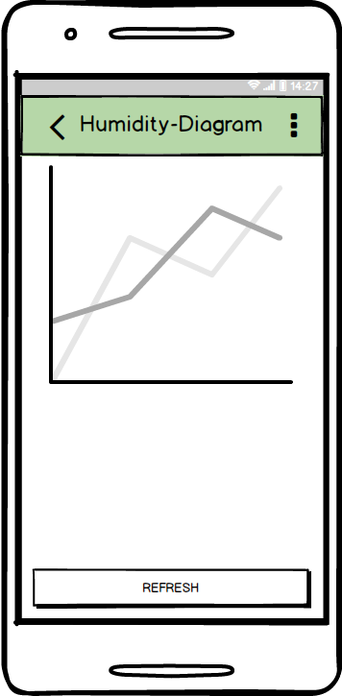

# Flow of Events

## Basic Flow

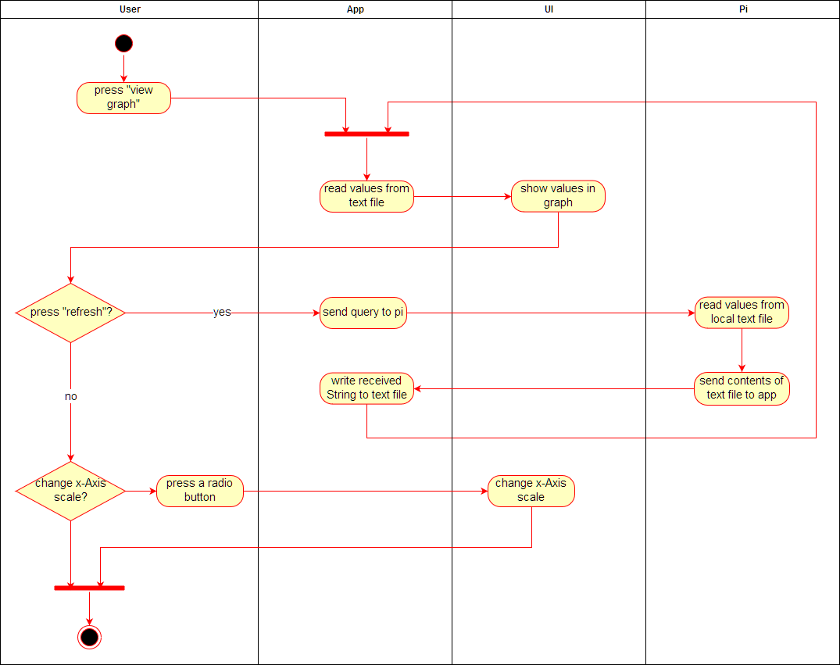

# Espresso test

# Preconditions

The app needs an active connection to the Pi. Also the user has to enter the “Single Plant Menu”.

# Postconditions

The graph will show the course of the humidity.

# FP-Calculation

